JAVA

ADDITION MATRIX:
CODE:
import java.util.*;
class Main {
public static void main(String[] args) {
Scanner sc = new Scanner(System.in);
System.out.println("Enter the number: ");
int n = sc.nextInt();
int[][] arr1 = new int[n][n];
int[][] arr2 = new int[n][n];
int[][] res = new int[n][n];
System.out.println("Enter the element for arr1: ");
for(int i = 0; i < n; i++){
for(int j = 0; j < n; j++){
arr1[i][j] = sc.nextInt();
}
}
System.out.println("Enter the element for arr2: ");
for(int i = 0; i < n; i++){
for(int j = 0; j < n; j++){
arr2[i][j] = sc.nextInt();
}
}
for(int i = 0; i < n; i++){
for(int j = 0; j < n; j++){
res[i][j] = arr1[i][j] + arr2[i][j];
}
}
System.out.println("Sum of two matrix is : ");
for(int i = 0; i < n; i++){
for(int j = 0; j < n; j++){
System.out.print(res[i][j] + " ");
}
System.out.println();
}
sc.close();
}
}
OUTPUT:
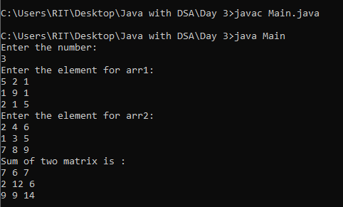

TRANSPOSE MATRIX:
CODE:
import java.util.*;
class Transpose{
public static void main(String[] args){
Scanner sc=new Scanner(System.in);
System.out.println("Enter the number: ");
int n=sc.nextInt();
int[][] arr1=new int[n][n];
System.out.println("Enter the element for arr1: ");
for(int i=0;i<n;i++){
for(int j=0;j<n;j++){
arr1[i][j]=sc.nextInt();
}
}
System.out.println("old matrix : ");
for(int i=0;i<n;i++){
for(int j=0;j<n;j++){
System.out.print(arr1[i][j]+" ");
}
System.out.println();
}
System.out.println("new matrix : ");
for(int i=0;i<n;i++){
for(int j=0;j<n;j++){
System.out.print(arr1[j][i]+" ");
}
System.out.println();
}
}
}
OUTPUT:
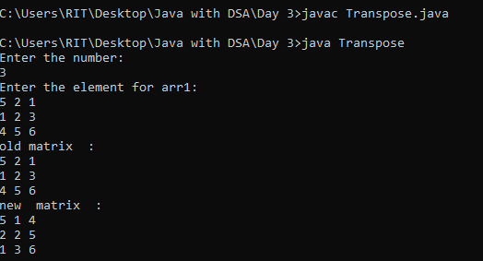
SPIRAL MATRIX:
CODE:
import java.util.*;
class Spiral {
public static void main(String[] args) {
Scanner s = new Scanner(System.in);
int n = s.nextInt();
int[][] arr1 = new int[n][n];
System.out.println("Enter the arr1:");
for (int i = 0; i < n; i++) {
for (int j = 0; j < n; j++) {
arr1[i][j] = s.nextInt();
}
}
int top = 0;
int bottom = n - 1;
int left = 0;
int right = n - 1;
while (top <= bottom && left <= right) {
System.out.print("Top");
for (int i = left; i <= right; i++) {
System.out.print(arr1[top][i] + " ");
}
top++;
System.out.print("Right");
for (int i = top; i <= bottom; i++) {
System.out.print(arr1[i][right] + " ");
}
right--;
System.out.print("Bottom");
if (top <= bottom) {
for (int i = right; i >= left; i--) {
System.out.print(arr1[bottom][i] + " ");
}
bottom--;
}
System.out.print("Left");
if (left <= right) {
for (int i = bottom; i >= top; i--) {
System.out.print(arr1[i][left] + " ");
}
left++;
}
}
}
}
OUTPUT:
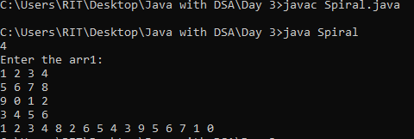

SADDLE POINT:
CODE:
import java.util.*;
class Saddle {
public static void main(String[] args) {
Scanner s = new Scanner(System.in);
int n = s.nextInt();
int[][] arr1 = new int[n][n];
System.out.println("Enter the arr1:");
for (int i = 0; i < n; i++) {
for (int j = 0; j < n; j++) {
arr1[i][j] = s.nextInt();
}
}
boolean found=false;
for(int i=0;i<n;i++){
int mincol=0;
for(int j=1;j<n;j++){
if(arr1[i][j]<arr1[i][mincol]){
mincol=j;
}
}
boolean saddle=true;
for(int k=0;k<n;k++){
if(arr1[k][mincol]>arr1[i][mincol]){
saddle=false;
break;
}
}
if(saddle){
System.out.println("Saddle point="+arr1[i][mincol]);
found=true;
break;
}
}
if(!found){
System.out.println("No saddle point");
}
}
}
OUTPUT:
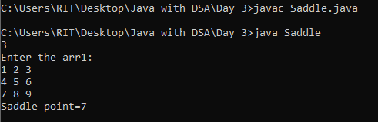

PYRAMID PATTERN:
CODE:
import java.util.*;
class pyramid{
public static void main (String[] args) {
Scanner s=new Scanner(System.in);
int n=s.nextInt();
for(int i=1;i<=n;i++){
for(int j=1;j<=n-i;j++){
System.out.print(" ");
}
for(int k=1;k<=i*2-1;k++){
System.out.print("*");
}
System.out.println();
}
}
}
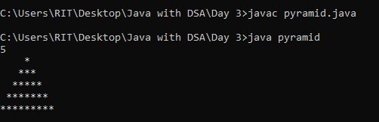

HALLOW PYRAMID:
CODE:
import java.util.*;
class hallowpyramid{
public static void main (String[] args){
int n=5;
for(int i=1;i<=n;i++){
for(int j=1;j<=n-i;j++){
System.out.print(" ");
}
for(int k=1;k<=(2*i-1);k++){
if(k==1 || k==(2*i-1) || i==n){
System.out.print("*");
}
else{
System.out.print(" ");
}
}
System.out.println();
}
}
}

OUTPUT:
